|  |  |
| --- | --- |
| **ArchSoc Symposium 2023** |  |

**Topic: Other Heritages:   
Preservation and Destruction**

**When: Saturday 26 August 2023**

**Time: 09h00 to 13h00**

**Venue: Delta Environmental Centre,** **Delta Park,   
Road No 3, Victory Park, Johannesburg.**

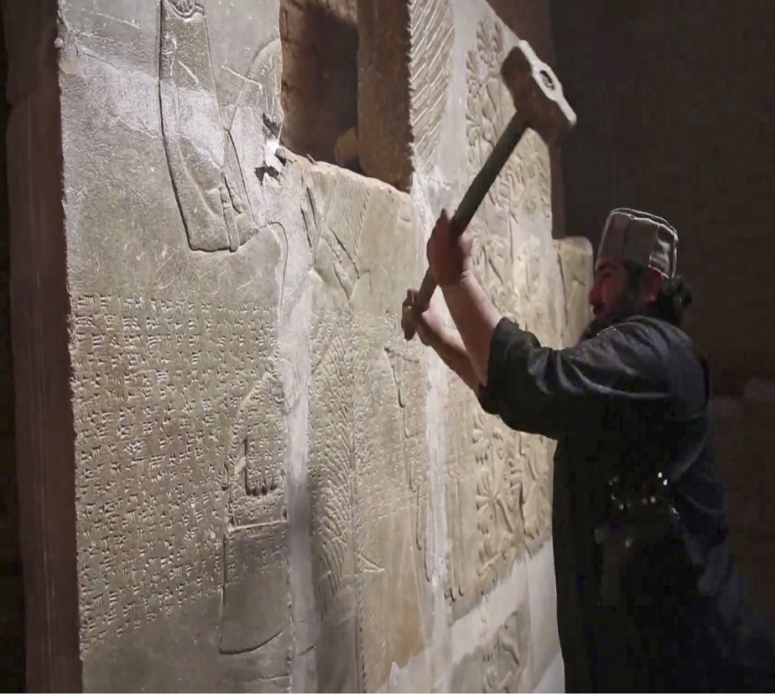

**Organised by the Northern Branch of the   
South African Archaeological Society.**

**Registration: 09h00 to 09h30**

**Venue:** Delta Environmental Centre, Delta Park, Road No 3, Victory Park, Johannesburg.

**Parking:** Secure parking at the Centre.

**Catering:** Bring your own picnic lunch and refreshing drink to enjoy with the other participants at the tables outside the Environmental Centre or on the lawns. A glass of fruit juice is available upon registration, and tea and coffee will be served at mid-morning.

*The auditorium at Delta Environmental Centre can get chilly, so bring a blanket for your knees.*

**Fees:** See page 6 of this flyer for the fees. Please note that the student fee is only applicable to full-time students.

**Book Table:**A wide selection of new and second-hand books will be available for purchasing before the symposium starts and during the morning tea break and at the end of the symposium.

The Northern Branch’s Annual Symposium brings academics, society members, and their friends together once a year for a series of fascinating lectures.

This year’s theme is about archaeological artefacts, monuments and sites that are threatened by warfare, looting, urbanisation, religious intolerance, major infrastructure projects and climate change.

Fortunately, there are activist organisations and individuals that are implementing ways of identifying, mapping, and monitoring such endangered sites.

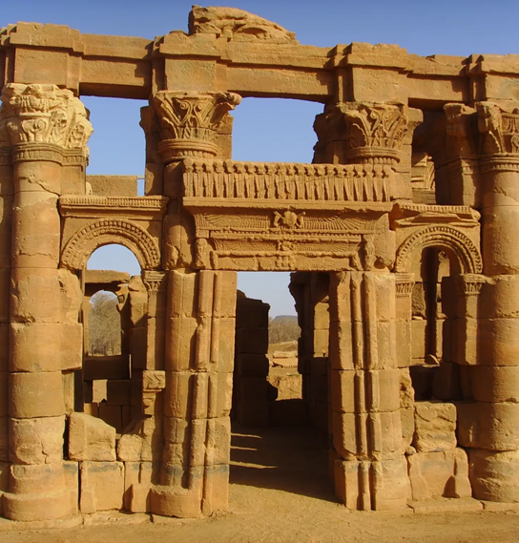

**Join us at the ArchSoc Symposium to hear first-hand the fascinating accounts of Prof. Cynthia Kros,   
PhD candidate Jane Marston and Dr Faye Lander,  
on the preservation and destruction of archaeological sites and monuments** **in** **places like** **Iraq, Benin, Mali, Ghana, Sudan, Kenya, Tanzania, and Zimbabwe.**

***Endangered Apedamak Temple at Naqa, Sudan.***

**PROGRAM: Saturday, 26 August 2023**

**Talk 1 – Was Cleopatra Black, and Why Does it Matter?**

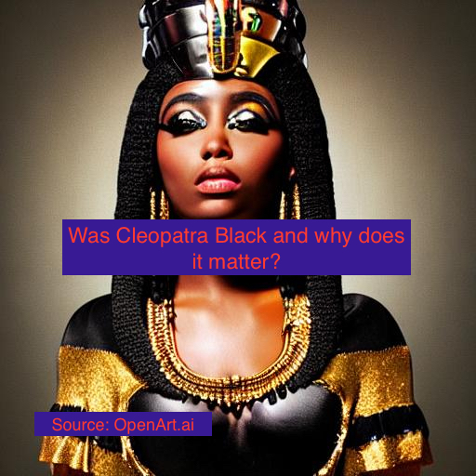**By Professor Cynthia Kros.**

Cynthia Kros will review the heated controversy over a Black woman being cast as Cleopatra in Netflix’s documentary series (May 2023). She explores issues related to ownership and custodianship of ‘world heritage’. She then moves on to the recent transfer to the government of the republic of Benin of 26 ceremonial objects, including statues, looted from the Palace of Abomey in 1892 and since then housed in French museums. Finally, she explores the complicated politics of restitution. Were these objects nothing but prisoners of the Quai Branly Museum in Paris?

Cynthia Kros is a historian and heritage specialist, with a PhD from Wits. Among her publications are a monograph, *The Seeds of Separate Development: Origins of Bantu Education* (2010), and many papers in academic journals in the fields of history, history education and heritage. She is one of the editors of two collections of essays, *Archives of Times Past: Conversations about South Africa’s Deep Past* (2022) and *Reframing Africa: Reflections on Modernity and the Moving Image* (2022). At Wits, she worked in the History Department for 18 years and thereafter was the Head of the Department of Arts, Culture and Heritage Management in the Wits School of Arts until 2014.

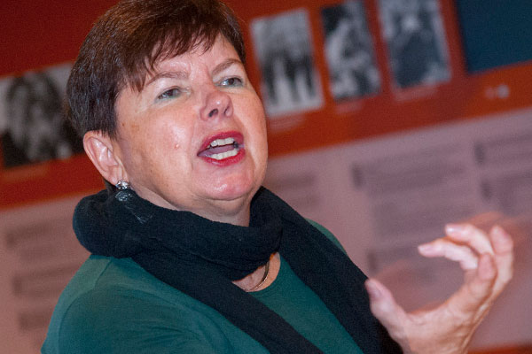

**Talk 2 – Modern War on Ancient Civilizations.**

**By PhD candidate Jane Marston.**

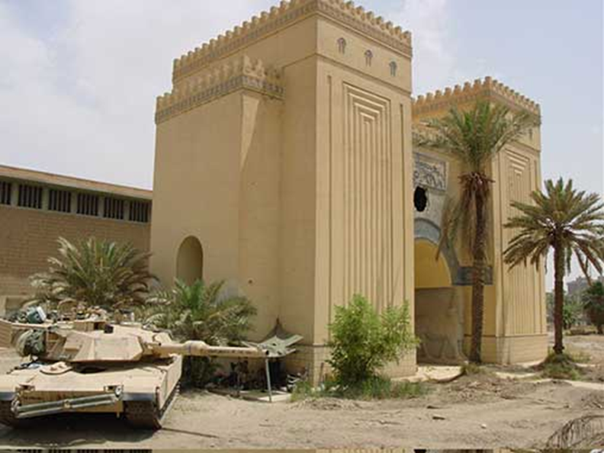

***View of a US tank outside a reconstructed Assyrian gate at the entrance to the children’s section of the Iraq National Museum. The gaping hole in its façade was made by US tank round. Photo courtesy of Joanne Farchakh-Bajjaly.***

Dr Jane Marston will explain the steps taken by archaeologists and other groups to alert the US government and military forces to the dangers of looting during the American invasion of Iraq in 2002. She then details the steps taken by the staff of the National Museum of Iraq to cope with the looting, which followed upon the invasion. Finally, she deals briefly with the destruction caused to archaeological sites by military occupation and looting, and with the devastation caused to the ancient site of Babylon.

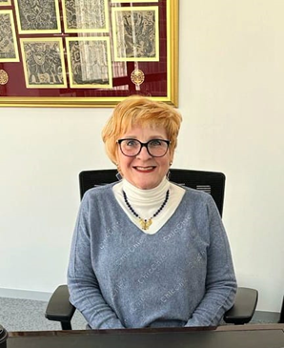

Jane Marston is a practising attorney with her own law practice in Sandton. She holds a doctorate in law (on racial hate speech) through the University of Pretoria. She also holds a Master’s degree in archaeology and is currently enrolled for a PhD at UNISA. This doctorate deals with the effects of modern warfare on the ancient Near East, the sanctions currently in place, why they don’t work and suggestions for the future.

**Talk 3 – Documentation and Monitoring of Africa’s Endangered Archaeological Sites and Monuments**

**By Dr Faye Lander**

Faye Lander will discuss the work being done by the *Mapping Africa’s Endangered Archaeological Sites and Monuments* (MAESaM) project.

The MAEASaM project aims to establish a secure publicly accessible web-based repository of sites and monuments records across Africa. The ambition of the project is to harmonise heterogeneous archaeological datasets deriving from diverse African regions with the goal to raise the visibility and profile of Africa’s heritage sites and monitor the multiple levels of threats.

In this talk, she will discuss the ongoing work within the project and draw upon regional case studies from West, Eastern and Southern Africa for the mapping and documentation of new and endangered heritage sites.

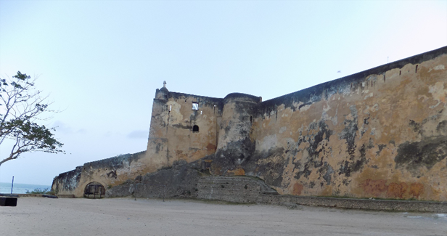

***Fort Jesus in Mombasa, constructed by the Portuguese between 1593 and 1596 to influence the Indian Ocean trade. The base of the fort was severely eroded before the protective wall was added. Photograph by Angela Kabiru, MAEASaM-BIEA Research Fellow for Kenya.***

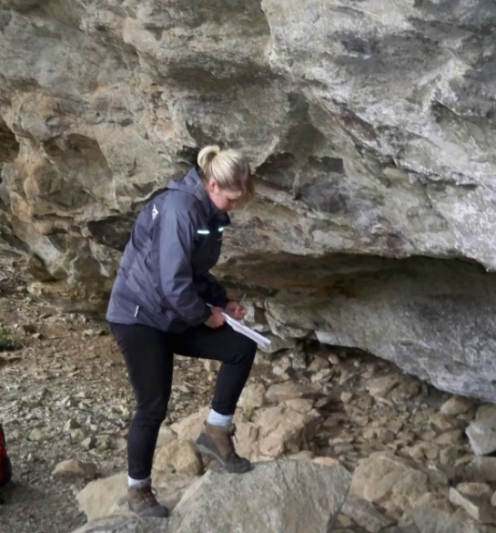

Faye Lander is part of the *Mapping Africa’s Endangered Archaeological Sites and Monuments* (MAEASaM) project, a multi-disciplinary collaborative project seated at the University of Cambridge, UK. In her current role, Faye coordinates the work being conducted in Southern Africa, particularly for Zimbabwe and Botswana, acting as Regional Project Manager based at the MAEASaM Research Hub at the Origins Centre, Wits University. She holds a PhD in African Archaeology, from Wits and has published more than 20 papers on various aspects of archaeology.

**Registration Details**

To register, email your details to [anner@mweb.co.za and](mailto:anner@mweb.co.za%20and) enclose *ONLY THIS PAGE* of the Symposium notification. **Bookings open on 17 July 2023**

Please provide the following:

1. Your name and those of any other people accompanying you to the symposium.
2. Whether you and those accompanying you are members of ArchSoc or not.
3. Your email address and cell phone number.

**Names of attendees: (Title, First name and Surname):**

|  |  |
| --- | --- |
| **Title, First name and Surname** | **Member** |
|  | Yes / No |
|  | Yes / No |
|  | Yes / No |
|  | Yes / No |

Email address: …………………………………………………………………………………

Cell Phone: …………………………………………………………………………………

**Fees payable: Please pay by EFT, if possible. Total**

|  |  |
| --- | --- |
| Members @ R160 pp | R |
| Non-members @ R210 pp | R |
| Students @ R70 pp | R |
| If depositing cash, please add R50 per payment to cover bank charges | R |
| **Total amount due** | R |

**FEES ARE PAYABLE IN ADVANCE TO:**

**Bank:** Standard Bank

**Account name:** SA Archaeological Society

**Account No: 001 945 920**

**Reference:** Surname and ‘Symposium’.

**E-mail proof of payment** to Anne Raeburn at [anner@mweb.co.za](mailto:anner@mweb.co.za)

If you wish to check on your booking, please phone Anne Raeburn on or after 14 August 2023 on 072 349 6507 during Business Hours.

**……………………………………….**